- First prompt – explained to chatgpt pro what we are going to do:
As a QA, I need to continue developing our Task Tracker App as requested below, As a start I need u to make sure you have everything to help me, don't do anything before I tell u what to do we need to keep track of the below requested docs, I will be selecting the Features, for now just tell me if everything is clear or u need extra things.
Reply:
Everything is clear, and I have the uploaded project archive ready as the starting point.
I will not inspect, modify, run, or generate anything until you tell me what to do.
The only detail that may need confirmation later is the documentation folder path: one section says docs/, while the final submission checklist says docs/midcourse/. I would follow docs/midcourse/ unless your instructor confirms otherwise.
Once you select the two features, we can track:
- branch: mid-course-project
- baseline app and pytest results
- user stories and acceptance criteria
- mini-ADR
- prompt log with accepted, edited, and rejected AI output
- implementation and verification evidence
- at least four new pytest tests
- Break Test evidence for at least two tests
- final reflection and README updates
No additional files are needed at this point.

- Feature selection: Feature 2: prompt 1:
so As a QA doing a mid course project I will select the second feature option "Tags/Labels" as a first we do not need to write any code, we need to prepare 3 to 5 user stories for the selected feature having the following format Each story must include acceptance criteria Example: Story: As a team member, I want to be able to add Tags for each task on creation and on edit so I can track my work. Acceptance Criteria: Tags should not be empty; missing tags returns 422 Description is optional: the tags appears in the Task div. Now generate 5 more stories in the same format
Reply:
Story 1
Story: As a team member, I want to assign multiple tags to a task so I can categorize the same task under more than one area of work.
Acceptance Criteria:
- A task can contain more than one tag.
- Each tag is saved and returned with the task.
- All assigned tags appear on the task card.
Description: Tags are displayed as separate labels inside the task card.

Story 2
Story: As a team member, I want tag values to be trimmed so accidental spaces do not create incorrect or duplicate-looking tags.
Acceptance Criteria:
- Leading and trailing spaces are removed from every tag.
- A tag containing only spaces is rejected.
- Invalid empty tag values return 422 Unprocessable Entity.
Description: A value such as " Backend " is stored and displayed as "Backend".

Story 3
Story: As a team member, I want to update the tags of an existing task so I can keep its categories accurate when the work changes.
Acceptance Criteria:
- Tags can be added or removed through the Edit Task modal.
- Saving the edit updates the task through the existing PATCH behavior.
- The updated tags appear on the task card after the request succeeds.
- Other task fields remain unchanged when only tags are updated.
Description: Editing tags must not overwrite unrelated task information.

Story 4
Story: As a team member, I want tasks without tags to remain valid so tags can stay optional when categorization is not needed.
Acceptance Criteria:
- A task can be created without tags.
- A task with no tags is successfully returned by the API.
- The task card does not show empty tag chips or placeholder tag values.
- Existing create and edit behavior continues to work without tags.
Description: Tags are optional and should not prevent normal task creation.

Story 5
Story: As a team member, I want to filter tasks by tag so I can quickly find tasks belonging to a specific category.
Acceptance Criteria:
- A tag filter is available in the frontend.
- Selecting a tag displays only tasks containing that tag.
- A filter with no matching tasks displays the existing empty states.
- Clearing the filter restores all tasks.
- Filtering does not change or delete task data.
Description: The filter helps users locate tagged tasks while keeping the Kanban columns visible.

- Fixing User Story 1 prompt:
So I need u to mention specifically in story 1 that on creation of Tasks, Tags can be created & assigned, do not change other userstories keep them aside
Reply:
Absolutely. Here's Story 1 updated only, with the creation requirement made explicit. The other user stories remain unchanged.
Story 1
Story: As a team member, I want to be able to create and assign one or more tags when creating a new task so I can categorize my work from the moment the task is created.
Acceptance Criteria:
- One or more tags can be added during task creation.
- Each tag is saved and associated with the newly created task.
- All assigned tags appear on the task card after the task is created.
- A task can still be created without tags if tags are optional.
Description: Tags can be created and assigned while creating a new task, and they are displayed as separate labels on the task card.

- Regenerating the User stories prompt:
it s good so now resend the full set of userstories while updating the first user story as approved now do not change the other user stories
Reply: Combining latest fixed Story with old ones
Story 1
Story: As a team member, I want to be able to create and assign one or more tags when creating a new task so I can categorize my work from the moment the task is created.
Acceptance Criteria:
- One or more tags can be added during task creation.
- Each tag is saved and associated with the newly created task.
- All assigned tags appear on the task card after the task is created.
- A task can still be created without tags if tags are optional.
Description: Tags can be created and assigned while creating a new task, and they are displayed as separate labels on the task card.

Story 2
Story: As a team member, I want tag values to be trimmed so accidental spaces do not create incorrect or duplicate-looking tags.
Acceptance Criteria:
- Leading and trailing spaces are removed from every tag.
- A tag containing only spaces is rejected.
- Invalid empty tag values return 422 Unprocessable Entity.
Description: A value such as " Backend " is stored and displayed as "Backend".

Story 3
Story: As a team member, I want to update the tags of an existing task so I can keep its categories accurate when the work changes.
Acceptance Criteria:
- Tags can be added or removed through the Edit Task modal.
- Saving the edit updates the task through the existing PATCH behavior.
- The updated tags appear on the task card after the request succeeds.
- Other task fields remain unchanged when only tags are updated.
Description: Editing tags must not overwrite unrelated task information.

Story 4
Story: As a team member, I want tasks without tags to remain valid so tags can stay optional when categorization is not needed.
Acceptance Criteria:
- A task can be created without tags.
- A task with no tags is successfully returned by the API.
- The task card does not show empty tag chips or placeholder tag values.
- Existing create and edit behavior continues to work without tags.
Description: Tags are optional and should not prevent normal task creation.

Story 5
Story: As a team member, I want to filter tasks by tag so I can quickly find tasks belonging to a specific category.
Acceptance Criteria:
- A tag filter is available in the frontend.
- Selecting a tag displays only tasks containing that tag.
- A filter with no matching tasks displays the existing empty states.
- Clearing the filter restores all tasks.
- Filtering does not change or delete task data.
Description: The filter helps users locate tagged tasks while keeping the Kanban columns visible.

- New Chat Prompt
In a new chat now I need to have the plan so we can add the feature into the existing App:
So As a QA, I've developed the Task tracker Application with a Python/FastApi backend and simple web Front end, I'm going to share the existing App folder. So now I'm adding a new feature to the existing App. Here are my key user stories: ### Story 1

**Story:** As a team member, I want to be able to create and assign one or more tags when creating a new task so I can categorize my work from the moment the task is created.

**Acceptance Criteria:**

* One or more tags can be added during task creation.
* Each tag is saved and associated with the newly created task.
* All assigned tags appear on the task card after the task is created.
* A task can still be created without tags if tags are optional.

**Description:** Tags can be created and assigned while creating a new task, and they are displayed as separate labels on the task card.

---

### Story 2

**Story:** As a team member, I want tag values to be trimmed so accidental spaces do not create incorrect or duplicate-looking tags.

**Acceptance Criteria:**

* Leading and trailing spaces are removed from every tag.
* A tag containing only spaces is rejected.
* Invalid empty tag values return `422 Unprocessable Entity`.

**Description:** A value such as `" Backend "` is stored and displayed as `"Backend"`.

---

### Story 3

**Story:** As a team member, I want to update the tags of an existing task so I can keep its categories accurate when the work changes.

**Acceptance Criteria:**

* Tags can be added or removed through the Edit Task modal.
* Saving the edit updates the task through the existing PATCH behavior.
* The updated tags appear on the task card after the request succeeds.
* Other task fields remain unchanged when only tags are updated.

**Description:** Editing tags must not overwrite unrelated task information.

---

### Story 4

**Story:** As a team member, I want tasks without tags to remain valid so tags can stay optional when categorization is not needed.

**Acceptance Criteria:**

* A task can be created without tags.
* A task with no tags is successfully returned by the API.
* The task card does not show empty tag chips or placeholder tag values.
* Existing create and edit behavior continues to work without tags.

**Description:** Tags are optional and should not prevent normal task creation.

---

### Story 5

**Story:** As a team member, I want to filter tasks by tag so I can quickly find tasks belonging to a specific category.

**Acceptance Criteria:**

* A tag filter is available in the frontend.
* Selecting a tag displays only tasks containing that tag.
* A filter with no matching tasks displays the existing empty states.
* Clearing the filter restores all tasks.
* Filtering does not change or delete task data.

**Description:** The filter helps users locate tagged tasks while keeping the Kanban columns visible. Constraints: 1- this is not a production software 2- keep the tech stack simple and welll documented 3- do not change or add new features unless it s requested 4- do not modify existing app features 5- Do not suggest microservices. Docker or cloud deployment. Propose two different lightweight architectures (A and B). For each one provide:
Tech stack (specific libraries with versions) needed to implement the Tags feature.
Files that should be modified to support the selected feature.
Data model sketch for this feature.
Do not write any code, only plan.
Three main trade-offs compared to the other option. Keep both proposals simple enough for a solo QA to understand and maintain keep it simple with brief details

Reply:
Existing app summary
The uploaded app currently uses:
- Backend: Python 3.12, FastAPI, Pydantic
- Storage: In-memory dictionary in app/storage.py
- Frontend: Single vanilla HTML/CSS/JavaScript file
- Tests: Pytest with FastAPI TestClient
- PATCH behavior: Uses exclude_unset=True, which is suitable for updating only tags without overwriting other fields

Architecture A — Tags embedded directly in each task
Recommended for this app. Store tags as a list of trimmed strings inside every task.
Tech stack
No new runtime libraries are required.
Component | Library/version
API | FastAPI 0.115.12
Validation/models | Pydantic 2.11.4
Server | Uvicorn 0.34.2
Frontend | Existing vanilla HTML, CSS and JavaScript
Testing | Pytest already present in the project environment; pin its current version in requirements.txt or a development requirements file
Files to modify
app/models.py
Add an optional tags field to:
- TaskCreate
- TaskUpdate
- TaskResponse
Add tag validation that:
- Trims leading and trailing whitespace
- Rejects values that become empty after trimming
- Returns the normal Pydantic 422 response
- Defaults missing tags to an empty list
- Defines whether duplicate tags such as "Backend" and "Backend" are removed
app/storage.py
Update:
- add_task() to save the validated tags
- get_all_tasks() to optionally filter tasks by an exact tag
- update_task() to replace tags only when tags is supplied in PATCH
No separate tag storage is needed.
app/main.py
Add an optional tag query parameter to the existing endpoint:
- GET /tasks?tag=Backend
Pass it to storage.get_all_tasks().
No new endpoint is required.
frontend/index.html
Modify the existing single-page frontend to add:
- Tags input in the Create Task modal
- Tags input in the Edit Task modal
- Tag chips on task cards
- A tag-filter control above the Kanban board
- Client-side parsing of entered tags
- Empty-state handling when no task matches
- Clear-filter behavior
The existing Kanban columns remain visible.
tests/test_tasks.py
Add API tests covering:
- Creation with one and multiple tags
- Creation without tags
- Trimming tag values
- Rejecting whitespace-only tags with 422
- PATCH adding, replacing and removing tags
- PATCH changing only tags while preserving other fields
- Filtering by an existing tag
- Filtering by a missing tag
- Clearing or omitting the filter
tests/conftest.py
Likely no structural change. Fixtures may be expanded with tagged-task helpers.
README.md
Document:
- The tags request and response field
- Tag input rules
- PATCH behavior
- GET /tasks?tag=...
- Example create, update and filter requests
Data model sketch
Task
├─ id: string
├─ title: string
├─ description: string
├─ status: TaskStatus
├─ priority: TaskPriority
├─ assignee: string | null
├─ tags: list[string] = []
├─ created_at: datetime
└─ updated_at: datetime
Example conceptual record:
Task:
title: "Verify login API"
tags:
- "Backend"
- "Regression"
For PATCH:
tags omitted → existing tags remain unchanged
tags: [] → all tags are removed
tags: ["Backend"] → existing tags are replaced
Main trade-offs compared with Architecture B
- Simpler, but duplicated values: The same tag text is stored independently on many tasks.
- Easy filtering, but no central tag catalogue: The frontend must derive available filter values from returned tasks.
- Minimal code, but limited future metadata: Adding tag colours, descriptions or IDs later would require a model change.

Architecture B — Separate tag catalogue with task-to-tag associations
Create a small central collection of tags and associate tasks with tag IDs. This is still kept inside the existing application and in-memory storage.
Tech stack
No new runtime libraries are required.
Component | Library/version
API | FastAPI 0.115.12
Validation/models | Pydantic 2.11.4
Server | Uvicorn 0.34.2
Frontend | Existing vanilla HTML, CSS and JavaScript
Testing | Existing Pytest/TestClient setup
Files to modify
app/models.py
Add:
- A small Tag model containing id and name
- Tag input validation models or shared validators
- A tags field in task create, update and response models
The public task response should still return readable tag names, so the frontend does not need to understand internal IDs.
app/storage.py
Add in-memory structures such as:
- _tags: tag ID to tag record
- _tag_name_index: normalized name to tag ID
- Task records containing associated tag IDs, or a separate task-to-tag mapping
Update storage operations to:
- Find or create tags during task creation
- Add or remove task associations during PATCH
- Convert tag IDs back to tag names in task responses
- Filter tasks by normalized tag name
- Clear tag storage in _reset()
app/main.py
Add the same optional tag filter to GET /tasks.
A separate tag endpoint is not necessary for the requested stories. The filter list can be built from task responses to avoid adding an unrequested feature.
frontend/index.html
Make the same visible changes as Architecture A:
- Create/edit tag input
- Tag chips
- Tag filter
- Clear-filter support
- Existing empty states
The frontend still sends and receives tag names; internal tag IDs stay hidden.
tests/test_tasks.py
Add the same user-story tests as Architecture A, plus checks that:
- Reusing "Backend" does not create separate internal tag records
- Trimmed equivalent values resolve to the same tag
- Removing a tag from one task does not remove it from another task
tests/conftest.py
Ensure both task storage and tag storage are reset between tests.
README.md
Document:
- Tag input remains a list of strings
- Tag names are centrally reused internally
- PATCH and filtering behavior
- Tags remain optional
Data model sketch
Task
├─ id: string
├─ title: string
├─ ...
└─ tag_ids: list[string]

Tag
├─ id: string
└─ name: string

TaskTag association
├─ task_id
└─ tag_id
In the current in-memory implementation, the association could be represented as:
_tasks[task_id].tag_ids = [tag_id_1, tag_id_2]
_tags[tag_id_1] = Tag(name="Backend")
API responses would still expose:
tags: ["Backend", "Regression"]
Main trade-offs compared with Architecture A
- More consistent tags, but more storage logic: One canonical tag is reused across tasks, but create, update and response conversion become more complex.
- Better future extensibility, but unnecessary abstraction today: Tag colours or metadata would be easier later, although they are not part of the current request.
- Less duplicated data, but more failure paths: Associations, indexes and cleanup require additional tests and maintenance.

Recommendation
Choose Architecture A.
It meets all five user stories with the smallest change to the existing design:
- No new dependencies
- No new API endpoints
- No separate persistence layer
- Existing PATCH semantics remain intact
- Tags stay optional
- Simple enough for one person to test and maintain
Architecture B is reasonable only when tags are expected to become managed entities with properties such as colours, descriptions or centralized administration. Those capabilities are not currently requested.

- Decision: Moving with architecture A after validation
- Progress:
So updated the code to support the tags
Added functions to the test_tasks.py and commented each tag function check with a comment
Now I moved to tag filtering in the backend
Then added the related tests
Then moved to the frontend

Screenshots
Adding a tag with lots of spaces to validate the trimming feature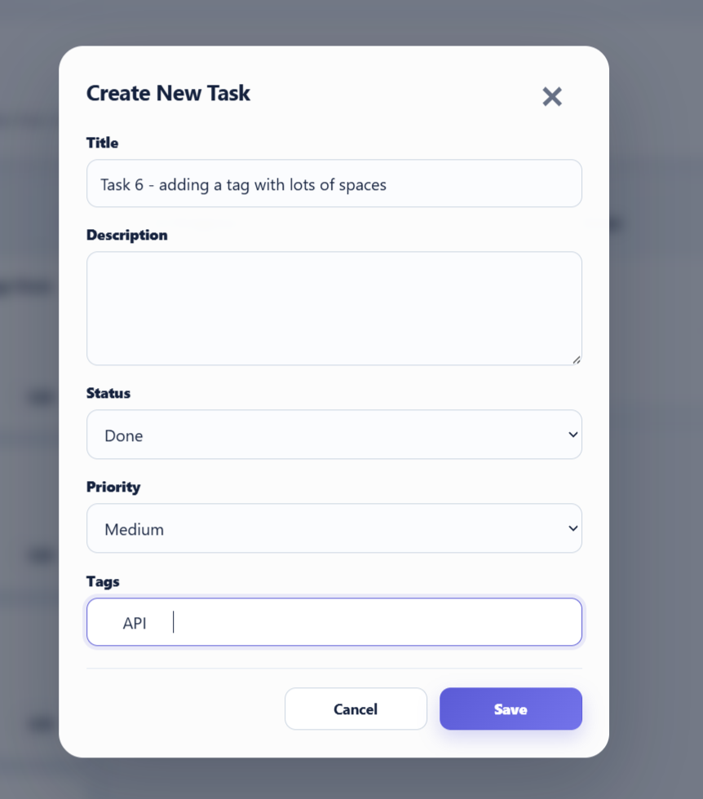

Tests made on the UI
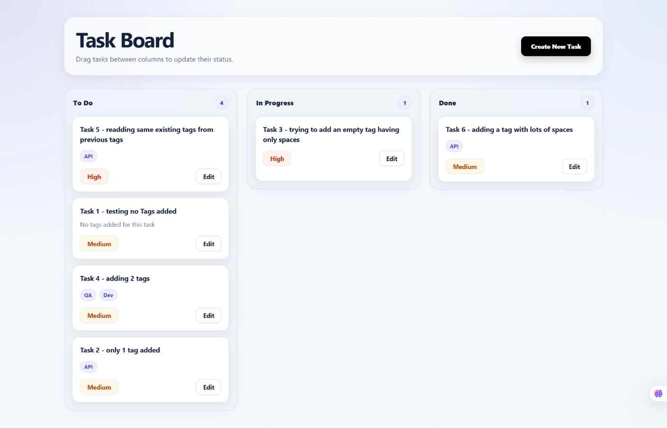

Removed previously added tag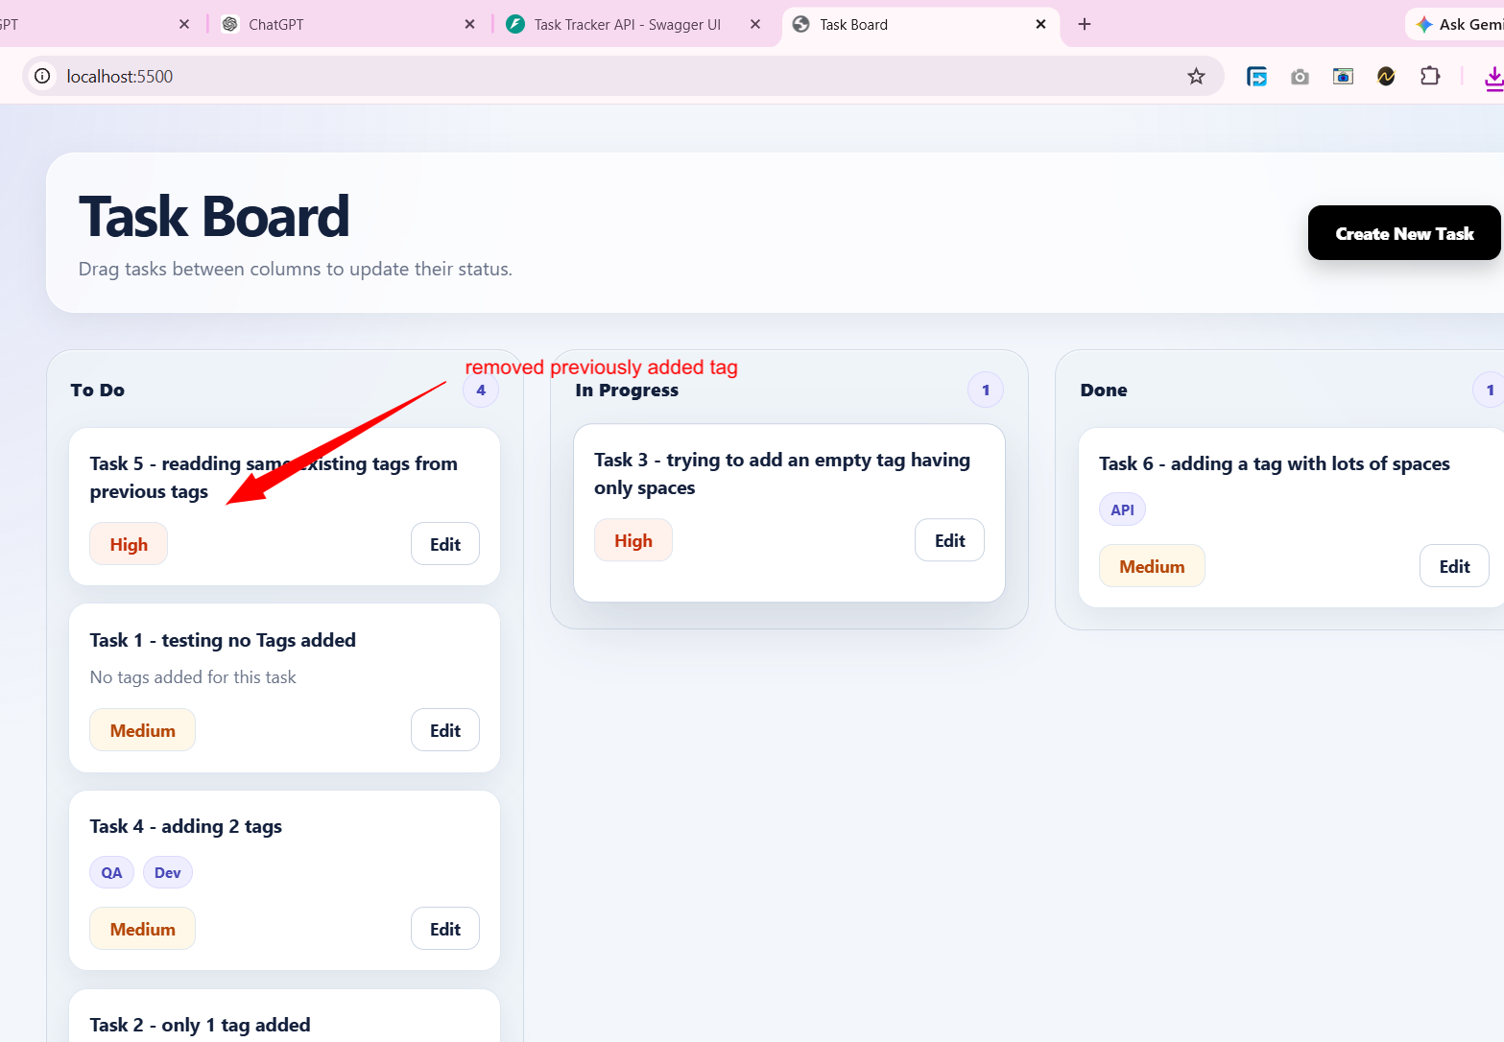

I think I can break the validation since we didn’t cover the following scenario which is that the tags are case sensitive
